**10 Oct 2014** **The Weekly Bulletin of Rotary Club of Kathmandu Mid-Town** **bc-14/10.014**

|  |
| --- |
|  |

District: 3292 Web:www.rotarymidtown.org.np Club Id: 26776

**OCTOBER IS VOCATIONAL SERVICE MONTH**

**Celebrating**

**25 Years in Rotary**





**The concept of vocational service:**

What is vocational service? If you are an active, engaged Rotarian, you probably view vocational service as a way of life, even if you find it difficult to articulate a clear definition.

The Object of Rotary is a philosophical statement of Rotary’s purpose and the responsibilities of Rotarians. The concept of vocational service is rooted in the Second Object, which calls on Rotarians to “encourage and foster”:

- High ethical standards in business and professions;

- The recognition of the worthiness of all useful occupations;

- The dignifying of each Rotarian’s occupation as an opportunity to serve society

As a Rotarian, how can you put these ideals into action? Consider these suggestions:

    Talk about your vocation in your club, and take time to learn about fellow members’ vocations

    Use your professional skills to serve a community

    Practice your profession with integrity, and inspire others to behave ethically through your own words and actions.

    Help a young person achieve his or her career aspirations.

    Guide and encourage others in their professional development.

If you do any of these things, you are performing vocational service. And if vocational service motivates and energizes you, then you’re in the right place, because vocational service is the very essence of Rotary. It is what sets Rotary apart from other service organizations.

*Source: Rotary International*

Friday, 26 September :

Regular weekly meeting # 1248 of the Club was held on Friday morning at Hotel Annapurna.

Extracts of the Meeting Minutes # 1248 are given below:

“7. A few remarks by the Acting President Rtn HE Peter Bodde

“ 8. A short talk by Mr. Lalit Bickram Shah who is the former regional director of ICAO Asia/Pacific Office on *Reminiscences of 40 years in the ICAO*. The International Civil Aviation Organization is a specialized agency of the United Nations. It codifies the principles and techniques of international air navigation and fosters the planning and development of international air transport to ensure safe and orderly growth. Mr Shah shared a lifetime of experience in the ICAO. Vote of thanks by Rtn. Larry.

“9. AOB and information sharing:

- Changa Chait cancelled for 27 Sept.

- ICM on Total Knee and Hip Replacement on 27 Sept 5PM, Indreni Foodland, New Baneswor

- PP Mani reminded that the handover for flood victims would take place today at 3PM at the Rotary Hall

- No breakfast meeting on 3 Oct

- Rtn Pabitra informed that the biogas project would begin within 30 days.

- Members present: 28 ”

# Weekly Meetings and Programs :

|  |  |  |
| --- | --- | --- |
| Date | Program/Speaker | Topic of Presentation |
| 3 October | Dashain holiday | ….. |
| 10 October | Sanjib Kumar Sharma | Snakebite in Nepal: Challenges and need |
|  |  |  |
|  |  |  |

Friday, 10 October :

Prof Dr Sanjib K Sharma, guest speaker for the morning, will be talking on **‘Snakebite in Nepal: challenges and need.’**

Snakebite envenoming is one of the most neglected diseases of the 21st century and affects several million people every year. It is most common in tropical and subtropical regions. The morbidity and mortality or long-term disability of young people that is caused by snakebite envenoming has profound socio-economic consequences for these developing nations.

Dr Sharma is a faculty member of Department of Medicine in BP Koirala Institute of Health Sciences, Dharan, Nepal. Prof Sharma did his MBBS, MD and FCCP from India. He is a Fellow of International Society of Nephrology (Italy), Fellow ISPD (Dialysis) (London, UK), Fellow JSN (Mie University, Japan). He did His DM (Cardiology) from Kathmandu University, Nepal.

He serves as Advisor to Global Snakebite Initiative, Australia, as Advisor to Asian Forum of CKD Initiative, Japan, and as member in many international committees.

**Changa Chait :** Saturday, 27 September

The program was cancelled.

*Source: Internet News*

**World Tourism Day :** 27 September

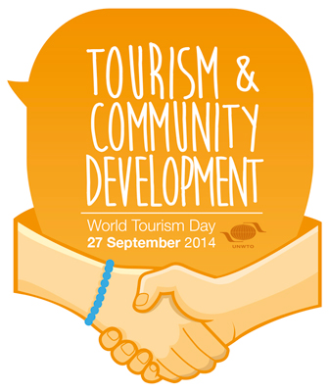

This year’s World Tourism Day draws special attention to the role of tourism in contributing

to one of the building blocks of a more sustainable future for all: Community development.

This focus is in line with the global transition to the Sustainable Development Goals as the

guiding principle promoted by the UN from 2015 and beyond.

As a sector representing 9% of global GDP, one in 11 jobs worldwide, and a key revenue

sector for developing and emerging economies, tourism is widely acknowledged for its

capacity to respond to global challenges. The consolidation of tourism’s economic

influence has built up its social responsibility and political relevance, with a growing

number of countries allocating a stronger mandate to tourism in economic and

development policy planning.

With the special focus on the community, WTD 2014 highlights how tourism can be

conducive to advancing sustainable development from the grassroots level. Community

based tourism involves the local population in the decision making process according to local priorities. The opportunity to become part of the tourism value chain actively involves host communities in the development process. Tourism thus becomes a catalyst of social cohesion, going beyond the immediate impact of job creation and its positive economic consequences and enhances,for instance, local governance capabilities which multiply the tourism impact even further.

It was in 1979 in Spain that the UNWTO General Assembly decided to institute the World Tourism Day on 27 September. This date was chosen to coincide with an important milestone in world tourism: the anniversary of the adoption of the UNWTO Statutes on 27 September 1970.

*Source: Internet News*

**World Heart Day: 29 September**



World Heart Day was founded in 2000 to inform people around

the globe that heart disease and stroke are the world’s leading

causes of death, claiming 17.3 million lives each year.

World Heart Day is an annual event which takes place on 29 Sept

every year. Each year’s celebrations have a different theme,

reflecting key issues and topics relating to heart health.

Together with World Heart Federation members, World Heart Day

spreads the news that at least 80% of premature deaths from

cardiovascular disease (CVD) could be avoided if four main risk factors – tobacco use, unhealthy diet, physical inactivity and harmful use of alcohol – are controlled.

The success of World Heart Day depends on the pro-activity of organizations from around the world to help us spread awareness of CVD, the world’s number one killer.

World Heart Day 2014 theme is: ‘Creating Heart-healthy Environments’.

The places in which we live, work and play should not increase our risk of CVD. But individuals frequently cannot make heart-healthy choices due to environmental factors, such as the availability of healthy food or smoke-free zones.

*Source: Internet News*

[**International Day of Older Persons**](http://targetstudy.com/knowledge/day/63/international-day-of-older-persons.html)**:** 1 October



The UN International Day of Older Persons is

celebrated annually on 1 October to recognize the

contributions of older persons and to examine issues

that affect their lives. It is an occasion when special

attention and focus on elderly care is highlighted.

Activities such as displays of promotional material on

importance of the Day in schools, offices buildings and

public places, media coverage, rallies by the elders to highlight their problems and submit petitions to the authorities are held on the Day. The International Day of Older Persons was observed for the first time throughout the world on 1 Oct 1991 following a decision of the UN General Assembly on 14 Dec 1990.

The theme of the 2014 commemoration is: “Leaving no one behind: Promoting a society for all”

"Leaving no one behind" necessitates the understanding that demography matters for

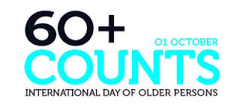

sustainable development and that population dynamics will shape the key develop-

mental challenges that the world is confronting in the 21st century. Not addressing

older person means not addressing 20 per cent of the global population by 2030,

where there will be more people over-60 than children under-10, with the most rapid

change in age structures in the developing world. Population over-60 is expected to

reach 1.4 billion by 2030.

*"Older persons make wide-ranging contributions to economic and social development. However, discrimination and social exclusion persist. We must overcome this bias in order to ensure a socially and economically active, secure and healthy ageing population." Secretary-General Ban Ki-moon*

*Source: Internet News*

**Dashain - Vijaya Dashami :** 3 October



Dashain is the biggest festival for the Hindus. It has its own stories, importance and

significance. It is regarded as the ‘victory of truth over the evil.’ Dashain is the celebration of

victory of good over bad. Dashain reminds us every year that the evil may be strong for a time;

the truth and good will always prevail over it.

The tenth day of the Dashain festival is **‘Vijaya Dashami'**. On this day, "tika", a mixture of [rice](http://en.wikipedia.org/wiki/Rice),

[yogurt](http://en.wikipedia.org/wiki/Yogurt) and [vermilion](http://en.wikipedia.org/wiki/Vermilion) and jamara, barley seedlings sown on the day of Ghatasthapana in

Dashain-ghar are provided by elders with blessings. The red vermilion tika also symbolizes

the blood that ties the family together. This continues to be observed for four or five days till

the full moon dur­ing which period families and relatives visit each other to exchange gifts and

greetings. This ritual of taking tika/jamara from the elders (even the distant relatives) helps in

the renewal of the community ties greatly. This is one reason why the festival is celebrated

with so much of vigor and enthusiasm.

In the Newar community of the Kathmandu Valley, Dashain is known as Mohani. There is slight difference in the way Mohani is celebrated in the community.

*Source: Internet News*

**World Teacher's Day :** 5 October

*“Teachers’ professional knowledge and skills are the most important factor for quality education. This World Teachers’ Day, we call for teachers to receive stronger training upfront and continual professional development and support.”*

*-*  *Irina Bokova, UNESCO Director-General*

World Teachers' Day was inaugurated on 5 Oct 1994 by the UNESCO



to commemorate the 1966 joint signing of the UNESCO/International

Labour Organisation (ILO) recommendation concerning the status of

teachers. Since then World Teachers’ Day has been celebrated on

5 October every year.

Celebrated in over 100 countries, World Teachers' Day acknowledges

the efforts of teachers in an increasingly complex, multicultural and

technological society. It is a day on which students, parents and community members can demonstrate their appreciation for the contributions that teachers have made to their community. Education in its broadest, general sense is the means through which the aims and habits of a group of people lives on from one generation to the next.

Teachers' day in Nepal is observed on the day of Guru Purnima. This year Guru Purnima was observed on July 13.

*Source: Internet News*

[**World Habitat Day**](http://targetstudy.com/knowledge/day/113/world-habitat-day.html)**:** 6 October



The UN World Habitat Day is annually celebrated on the first Monday of October to reflect

on the state of human settlements and people’s right to sufficient shelter. It also aims to

remind people that they are responsible for the habitat of future next generations.

Various activities around the world are organized to examine the problems of rapid

urbanization and its impact on the environment and human poverty.

The World Habitat Day was first celebrated in 1986 with the theme “Shelter is My Right”.

Nairobi was allocated as the host city for the observance that year. This annual event is

held on the first Monday of October with a new theme each year. An important highlight

of the day is the “Habitat Scroll of Honour” award, which was launched by the UN Human

Settlements Programme (UNHSP) in 1989. It is believed to be the world’s most prestigious

human settlements award and aims to acknowledge initiatives that make outstanding contributions in areas such as shelter provision, highlighting the plight of the homeless, leadership in post conflict reconstruction, and developing and improving the human settlements and the quality of urban life.

*Source: Internet News*

[**World Mental Health Day**](http://targetstudy.com/knowledge/day/117/world-mental-health-day.html)**:** 10 October

Mental disorders affect nearly 12 percent of the world’s population – about 450 million or

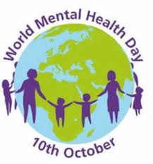

one out of every four people around the world – will experience a mental illness that would

benefit from diagnosis and treatment.

World Mental Health Day is an initiative of the World Federation for Mental Health (WFMH)

and is supported by the World Health Organization (WHO). The Mental Health Foundation

is another organization that is proactive in promoting World Mental Health Day. The WMH

Day is observed in more than 150 countries on 10 October through local, regional and

national organisations. In response to making mental health a global priority, World Health

Day was first celebrated in 1992 as an initiative of the WFMH. WFMH is an international

membership organization founded in 1948 to advance, among all peoples and nations,

the prevention of mental and emotional disorders, the proper treatment and care of those

with such disorders, and the promotion of mental health. The federation has members and

contacts in more than 150 countries on six continents. Each year the UN, through WHO, actively participates in promoting this event. World Mental Health Day, which is supported by the UN, is annually held on October 10 to raise public awareness about mental health issues worldwide

*Source: Internet News*

**Committee Chairs’ Column:** *(This column is for use by chairpersons of 5 permanent committees: Club Administration, Membership, Public Relations, Service Projects, and the Rotary Foundation)*

On Lighter Side :



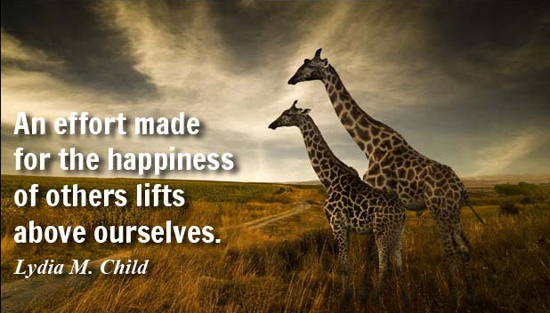

Great Quotes:

**[A life spent making mistakes is not only more honorable,](http://www.brainyquote.com/quotes/quotes/g/georgebern102967.html" \o "view quote)**

**[but more useful than](http://www.brainyquote.com/quotes/quotes/g/georgebern102967.html" \o "view quote)**

**[a life spent doing nothing.](http://www.brainyquote.com/quotes/quotes/g/georgebern102967.html" \o "view quote)**

- [George Bernard Shaw](http://www.brainyquote.com/quotes/authors/g/george_bernard_shaw.html)

**Members’ Corner:** *(This column is for Club members to express anything they would like in matter of Club activities, Club administration, Club issues or on Breakfast Chatter, or on anything else that would be of interest to fellow members.)*



There is a Chinese proverb: “If you want happiness for an hour, take a nap. If you

want happiness for a day, go fishing. If you want happiness for a year, inherit a

fortune. If you want happiness for a lifetime, help someone else.”

~~, these~~

**RI President GARY C.K. HUANG**

Please send information on club activities, progress reviews on service projects, relevant photos etc to:

BC Editor: RR Shrestha email: rryesrr@gmail.com

## 10 October 2014 The Weekly Bulletin of Rotary Club of Kathmandu Mid-Town bc-14/10.014